Predictive Modeling of Wildfire Activity and PM2.5 Air Quality Trends
Sowjanya Tammali* | Ph.D. Student, Missouri University of Science and Technology | sowjanya.tammali@mst.edu
Sadia Islam* | Ph.D. Student, Missouri University of Science and Technology | siqpf@mst.edu

Abstract
This project presents a two-channel data mining framework for analyzing wildfire activity and PM2.5 air-quality trends in California from 2015 to 2020. Channel I predicts next-month high wildfire activity at the county-month level using NASA FIRMS VIIRS fire detections. Channel II predicts PM2.5 air-quality trends using EPA AQS PM2.5 data and investigates whether wildfire activity contributes to elevated pollution levels. For Channel I, the proposed WFR-XGB model gives higher importance to high-fire months and recent fire-history intensity, improving high-fire recall from 0.57 to 0.73 compared with standard XGBoost. For Channel II, the WWTR model uses an asymmetric wildfire-weighted objective to reduce missed PM2.5 spike events. A final linking analysis based on lag correlation, partial correlation, and VAR/Granger causality is used to study the relationship between wildfire signals and PM2.5 outcomes. Overall, the results suggest that wildfire prediction and air-quality prediction can be jointly modeled at the county-month level to support early warning and atmospheric risk analysis. The source code can be found here: https://github.com/SowjanyaTammali/Datamining-class-project. Public data sources used in this work are NASA FIRMS VIIRSand EPA AQS and U.S. Census TIGER/Line county shapefiles.

1. Introduction
Wildfires are becoming more frequent and severe, especially in California. Their impact is not limited to burned land and damaged infrastructure. Wildfire smoke also produces fine particulate matter, known as PM2.5, which can enter the lungs and bloodstream and cause serious health risks. Because PM2.5 pollution can remain elevated after wildfire activity, predicting wildfire risk and air-quality degradation in advance is important for public health planning.
The main goal of this project is to study whether historical wildfire activity and PM2.5 measurements can be used to predict future wildfire risk and air-quality trends at the California county level. The project is divided into two channels. Channel I focuses on predicting next-month high wildfire activity using NASA FIRMS satellite fire detections. Channel II focuses on predicting PM2.5 levels using EPA AQS air-quality data. The final linking step connects both channels to examine whether high wildfire-risk months are associated with elevated PM2.5 levels in the same county.
This problem is challenging for several reasons. First, wildfire data and PM2.5 data are collected at different spatial scales: fire detections are point-level satellite observations, while PM2.5 values come from monitoring stations. Second, both wildfire activity and PM2.5 pollution have strong seasonal patterns. Third, high wildfire months are less frequent than normal months, so standard classifiers may become biased toward the majority class. Finally, wildfire effects on PM2.5 may appear with a time lag, making it necessary to study temporal relationships.

2. Related Works

2.1 Wildfire Prediction and Satellite-Based Fire Modeling
Recent wildfire prediction studies increasingly use satellite observations, remote sensing products, and machine learning models to predict wildfire occurrence, fire spread, or early-warning risk. Agrawal et al. proposed a machine learning approach for predicting large wildfires across the United States using environmental remote sensing and atmospheric reanalysis data. Their work is related to our Channel I because both use historical environmental observations to classify or predict wildfire risk, but our project focuses on California county-month prediction and connects the wildfire output to PM2.5 analysis [1].
Illarionova et al. explored geospatial data and machine learning algorithms for wildfire occurrence prediction. Their work shows that wildfire prediction benefits from spatial features and historical environmental patterns, which supports our use of county-level aggregation and recent fire-history features such as fire_rolling_3 and lagged fire variables [2].

Bhowmik et al. developed a multimodal wildfire prediction and early-warning framework using spatiotemporal machine learning. This is closely related to our motivation because both projects aim to support early warning. However, our Channel I focuses on improving recall for rare high-fire county-months using WFR-XGB, while their work emphasizes multimodal wildfire prediction at a broader early-warning level [3].

2.2 PM2.5 Prediction Using Machine Learning and Deep Learning
Recent PM2.5 prediction studies use deep learning, graph learning, and satellite-based models to capture spatial and temporal air-quality variation. Guo et al. proposed DeepAir, a California-focused PM2.5 estimation framework that combines satellite imagery, meteorological variables, and machine learning. This is highly related to Channel II because both projects study PM2.5 in California, but our project uses EPA AQS county-month aggregation and links PM2.5 behavior with wildfire-risk outputs [4].
Liu et al. proposed an EEMD-ALSTM model for PM2.5 concentration prediction, combining signal decomposition, attention, and LSTM. Their work supports the idea that temporal dependency is important for PM2.5 forecasting. Our project also uses lag and rolling PM2.5 features, but our final Channel II method focuses on asymmetric wildfire-weighted loss for spike detection rather than only sequence modeling [5].
Chen et al. proposed an adaptive adjacency matrix graph convolutional recurrent network for air-quality prediction. Their work shows the importance of spatial dependency between monitoring regions. This relates to our future work because our current county-month model can be extended with county adjacency or smoke-transport graph features [6].
Wang et al. proposed a spatiotemporal attention causal convolutional network for multi-site PM2.5 prediction. Their study is relevant because it addresses spatial and temporal PM2.5 variation across multiple sites. Our project uses a simpler county-month setup, but the linking analysis similarly studies temporal relationships between wildfire signals and PM2.5 outcomes [7].
Recent Work / Venue | Main Idea | Relation to our project
[1] Remote Sensing, 2023 | Large wildfire prediction using ML and remote sensing | Supports Channel I wildfire prediction
[2] Scientific Reports, 2025 | Geospatial ML for wildfire occurrence prediction | Supports county-level wildfire feature design
[3] Journal of Environmental Management, 2023 | Multimodal wildfire early-warning system | Related to early-warning motivation
[4] Machine Learning: Science and Technology, 2025 | DeepAir PM2.5 estimation in California | Related to Channel II PM2.5 modeling
[5] Scientific Reports, 2024 | EEMD-ALSTM for PM2.5 prediction | Supports temporal PM2.5 forecasting
[6] Scientific Reports, 2024 | Graph convolutional recurrent air-quality model | Supports future spatial graph extension
[7] Frontiers in Environmental Science, 2024 | Spatiotemporal attention CNN for PM2.5 | Related to temporal and spatial PM2.5 variation
[8] Environmental Data Science, 2025 | GNN-based PM2.5 forecast for fire impact | Directly related to wildfire-PM2.5 linkage
[9] NBER, 2024 | Wildfire smoke PM2.5 and mortality burden | Supports public-health importance
[10] Environmental Research, 2025 | Daily spatiotemporal PM2.5 ML model | Related to PM2.5 prediction with sparse monitors
[11] Environment International, 2020 | California PM2.5 estimation with multisource data including wildfire smoke | Directly relevant to Channel II wildfire-smoke-aware PM2.5 modeling
Table 1. Summary of related work and its connection to the proposed wildfire and PM2.5 framework.

2.3 Wildfire Smoke, PM2.5, and Air-Quality Impact Modeling
Recent studies specifically examine wildfire smoke and PM2.5 exposure using data-driven models. Liao et al. used graph neural network-based PM2.5 forecasts to simulate the air-quality impact of prescribed fires. This work is closely related because it links fire activity with PM2.5 concentration, although it focuses on prescribed-fire simulation rather than county-level wildfire-risk prediction and monthly PM2.5 forecasting [8].
Qiu et al. quantified the mortality burden associated with wildfire smoke PM2.5 under climate change. Although their focus is health impact rather than prediction, the study strongly motivates the public-health importance of anticipating smoke-related PM2.5 exposure [9].
XIS-PM2.5 is a recent daily spatiotemporal machine-learning model for estimating PM2.5 across the contiguous United States. It demonstrates the value of machine learning for reconstructing PM2.5 where monitoring is sparse. Our Channel II model is simpler in spatial resolution, but it similarly uses machine learning to estimate PM2.5 trends from structured environmental data [10]. A closely related California study by Li et al. fused multisource data, including wildfire smoke, to estimate PM2.5 at high spatiotemporal resolution. That study is especially relevant to our work because it explicitly models California PM2.5 behavior under wildfire influence, whereas our report focuses on county-month prediction and interpretable linking analysis [11].

2.4 Model Design: Imbalanced Classification and Asymmetric Loss
Several recent environmental prediction studies show that standard accuracy or symmetric loss functions may not be ideal for high-risk events. In our Channel I task, high-fire months are less frequent than normal months, so a model with high accuracy can still miss many dangerous months. This motivates WFR-XGB, which uses wildfire-aware sample weighting and threshold tuning to improve high-fire recall. In Channel II, the same idea appears as WWTR, where PM2.5 underestimation is penalized more heavily because missed pollution spikes are more harmful than false alarms. This design is consistent with recent air-quality forecasting work that prioritizes hazardous-event detection and practical warning performance over only minimizing average error [4], [8], [10], [11].

3. Proposed Method

3.1 Overall Framework
The proposed framework contains two prediction channels and one linking analysis. Channel I predicts next-month wildfire risk. Channel II predicts PM2.5 air-quality levels. Both channels are aggregated to the same county-month structure so they can be merged using county name, year, and month. The final linking stage analyzes whether predicted high wildfire activity contributes to elevated PM2.5 levels in the same county.
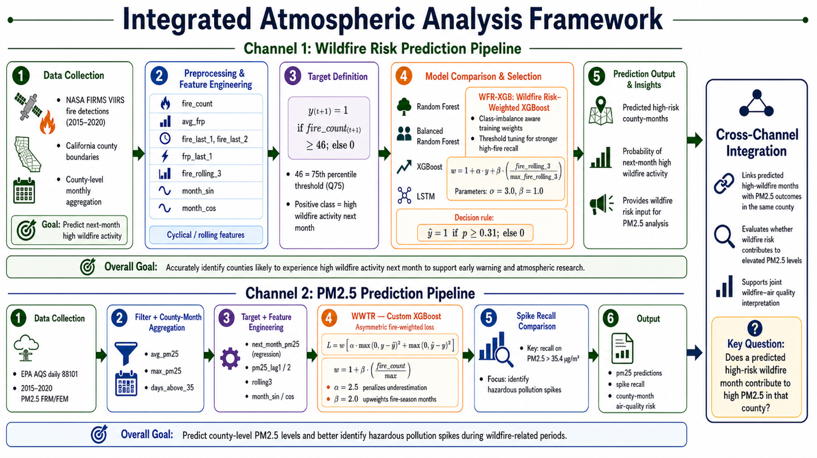
Figure 1. Integrated wildfire and PM2.5 prediction framework.

3.2 Channel I: Wildfire Risk Prediction
Channel I uses NASA FIRMS VIIRS active fire detections from 2015 to 2020. The raw fire points are filtered to California and spatially joined with California county boundaries. Fire detections are then aggregated by county and month.
The final features include:
- fire_count
- avg_frp
- fire_last_1
- fire_last_2
- frp_last_1
- fire_rolling_3
- month_sin
- month_cos
The binary target is defined in Equation (1):
label_next_month = 1 if fire_count₍t+1₎ ≥ 46; otherwise, 0 (1)
The threshold 46 corresponds to the 75th percentile of monthly wildfire activity. This makes the task a binary classification problem where class 1 represents high wildfire activity next month.

3.3 WFR-XGB: Wildfire-Recall Weighted XGBoost
Standard XGBoost uses binary logistic loss, but it does not directly account for the higher cost of missing high-fire months. In wildfire early-warning systems, false negatives are more harmful than false positives because missing a high-risk month may delay preparedness.
To address this, Channel I uses WFR-XGB, a Wildfire-Recall Weighted XGBoost model. It gives more importance to high-fire samples and to samples with stronger recent fire history.
Wildfire-aware sample weight is defined in Equation (2):
λᵢ = (αyᵢ + (1 - yᵢ)) × (1 + β × fire_rolling_3ᵢ / max(fire_rolling_3)) (2)
where α = 3.0 increases the weight for high-fire months and β = 1.0 increases the weight for recent fire-history intensity.
The weighted binary logistic loss is given in Equation (3):
L = -Σᵢ λᵢ [ yᵢ log(pᵢ) + (1 - yᵢ) log(1 - pᵢ)] (3)
where pᵢ is the predicted probability of high wildfire activity.
The final decision rule is given in Equation (4):

ŷᵢ = 1 if pᵢ ≥ 0.31; otherwise, 0 (4)
The threshold 0.31 is selected by sweeping thresholds from 0.10 to 0.90 and choosing the value with the best Class-1 F1-score.

3.4 Channel II: PM2.5 Air Quality Prediction
Channel II uses EPA AQS daily PM2.5 FRM/FEM data from 2015 to 2020. The raw daily station-level data is filtered to California and aggregated to county-month level. The aggregated variables include average PM2.5, maximum PM2.5, standard deviation, and number of days above the EPA threshold of 35.4 µg/m³.
The main features include:
- avg_pm25
- max_pm25
- days_above_35
- pm25_lag1
- pm25_lag2
- pm25_rolling3
- month_sin
- month_cos
The Channel II task is regression because it predicts future PM2.5 levels. It also evaluates spike detection using PM2.5 > 35.4 µg/m³.

3.5 WWTR: Wildfire-Weighted Temporal Regressor
Standard regression models usually minimize mean squared error, treating underprediction and overprediction equally. For PM2.5 forecasting, underprediction is more dangerous because it can miss hazardous pollution events. WWTR uses an asymmetric loss that penalizes underestimation more heavily.
The baseline mean squared error is shown in Equation (5):
L_MSE = (1/n) Σᵢ (yᵢ - ŷᵢ) ² (5)
WWTR sample weight is defined in Equation (6):
wᵢ = 1 + β × days_above_35ᵢ / max(days_above_35) (6)
where β = 2.0.
WWTR asymmetric loss is defined in Equation (7):
L_WWTR = (1/n) Σᵢ wᵢ [ α × max (0, yᵢ - ŷᵢ) ² + max (0, ŷᵢ - yᵢ) ²] (7)
where α = 2.5 penalizes underestimation more than overestimation.

3.6 Linking Analysis
After both channels generate outputs, the datasets are merged using county, year, and month. The linking analysis uses three steps:
- Lag correlation to test whether wildfire variables from previous months correlate with PM2.5.
- Partial correlation to control for seasonality.
- VAR/Granger causality to test whether past wildfire activity improves prediction of future PM2.5.

The lag-correlation statistic is defined in Equation (8):
r(k) = Pearson (FRP (t - k), PM2.5(t)) (8)
The seasonally adjusted partial correlation is defined in Equation (9):
r_partial = Pearson (residual (FRP | season), residual (PM2.5 | season)) (9)

4. Experimental Analysis

4.1 Datasets
Dataset | Source | Years | Final format
Wildfire detections | NASA FIRMS VIIRS-SNPP [12] | 2015–2020 | California county-month wildfire features
PM2.5 air quality | EPA AQS parameter 88101[13] | 2015–2020 | California county-month PM2.5 features
County boundaries | U.S. Census TIGER/Line [14] | 2020 | California county shapefile
Table 2. Datasets used for wildfire prediction, PM2.5 prediction, and county-level spatial aggregation.

4.2 Experimental Setup
A time-based split is used to avoid future data leakage. Records from 2015 to 2018 are used for training, and records from 2019 to 2020 are used for testing.
Split | Years | Purpose
Training | 2015–2018 | Model fitting
Testing | 2019–2020 | Final evaluation
Table 3. Time-based train-test split used for model development and final evaluation.
For Channel I, the evaluation metrics are accuracy, Class-1 precision, Class-1 recall, and Class-1 F1-score. Recall is prioritized because false negatives represent missed high-fire months. For Channel II, the evaluation metrics are MAE, RMSE, R², spike recall, and missed warnings.

4.3 Channel I Results
Model | Accuracy | Precision (C1) | Recall (C1) | F1 (C1)
Random Forest | 0.78 | 0.72 | 0.40 | 0.52
Balanced RF | 0.78 | 0.74 | 0.38 | 0.50
XGBoost | 0.76 | 0.59 | 0.57 | 0.58
LSTM | 0.65 | 0.36 | 0.64 | 0.46
WFR-XGB | 0.70 | 0.49 | 0.73 | 0.59
Table 4. Channel I model comparison on the 2019–2020 test set. WFR-XGB achieves the highest high-fire recall.
WFR-XGB improves Class-1 recall from 0.57 to 0.73 compared with standard XGBoost. This means it detects more high-fire months, which is important for early-warning use. The confusion matrix shows that WFR-XGB correctly detected 239 high-fire county-months and missed 89. The model sacrifices some overall accuracy but reduces the number of missed high-risk wildfire months.
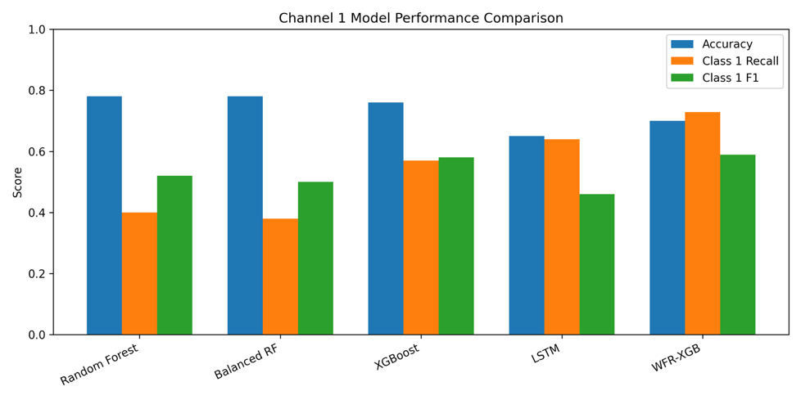
Figure 2. Channel I model performance comparison. WFR-XGB improves high-fire recall compared with standard XGBoost and other baseline models.
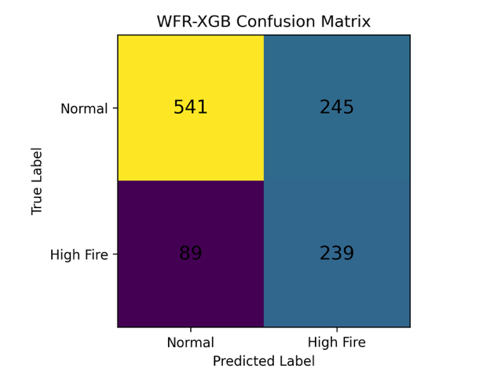
Figure 3. WFR-XGB confusion matrix. The model detected 239 high-fire months and missed 89 high-fire months.

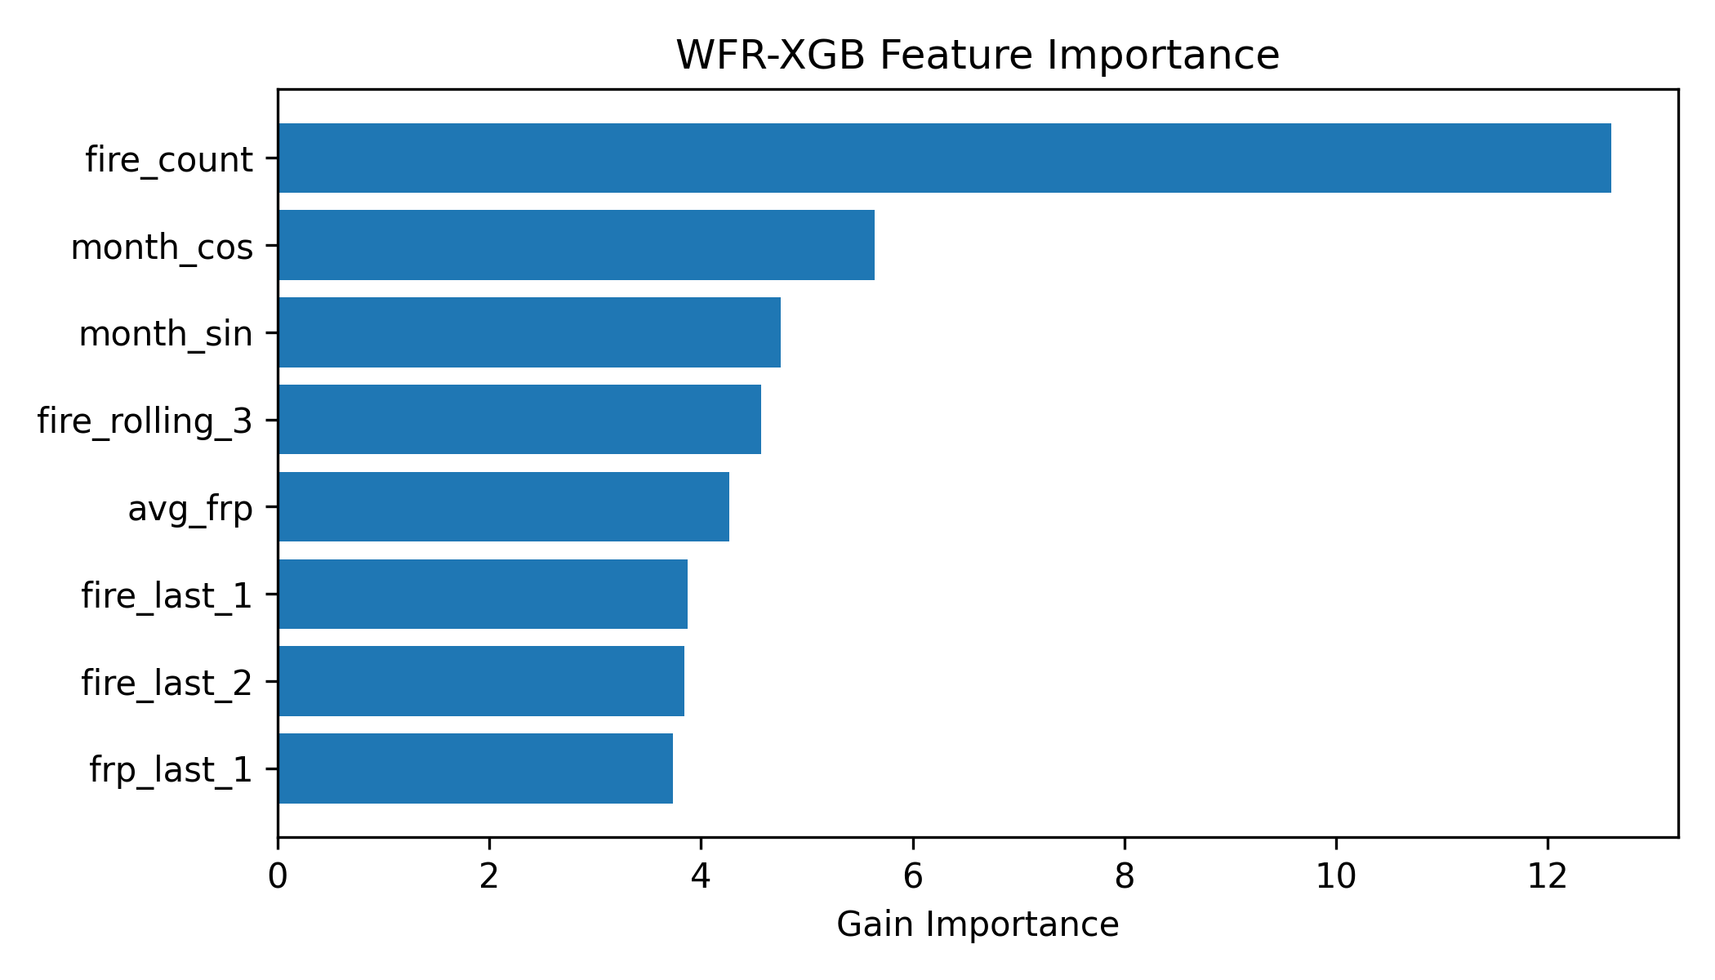
Figure 4. WFR-XGB feature importance. Fire count, seasonality, recent rolling fire activity, and average FRP are the strongest predictors.

4.4 Channel II Results
WWTR is designed to reduce missed PM2.5 spike events by penalizing underestimation more strongly. Although its RMSE is slightly higher than standard XGBoost, this tradeoff is acceptable for air-quality warning because underpredicting a hazardous PM2.5 spike is more harmful than issuing a false warning.
Model | MAE | RMSE | R²
Random Forest | 4.41 | 9.961 | 0.070
XGBoost (MSE) | 4.23 | 9.86 | 0.088
LSTM | 4.67 | 10.243 | 0.018
WWTR | 4.48 | 9.96 | 0.070
Table 5. Channel II PM2.5 prediction results on the 2019–2020 test set.
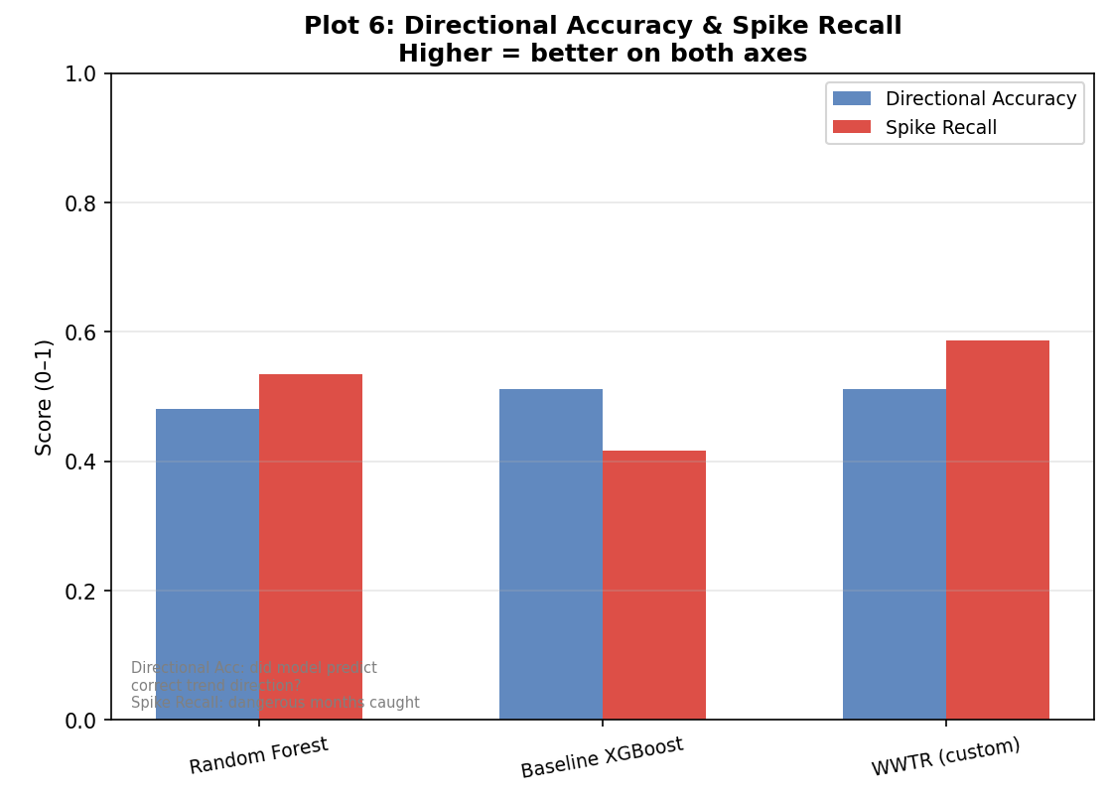
Figure 5. Channel II PM2.5 prediction comparison. WWTR is designed to improve spike detection by penalizing underestimation more heavily.
The experiments indicate that WWTR achieves the strongest spike-detection behavior among the compared models. It captures more PM2.5 spike events while maintaining competitive overall directional performance, whereas standard XGBoost produces fewer spike detections.
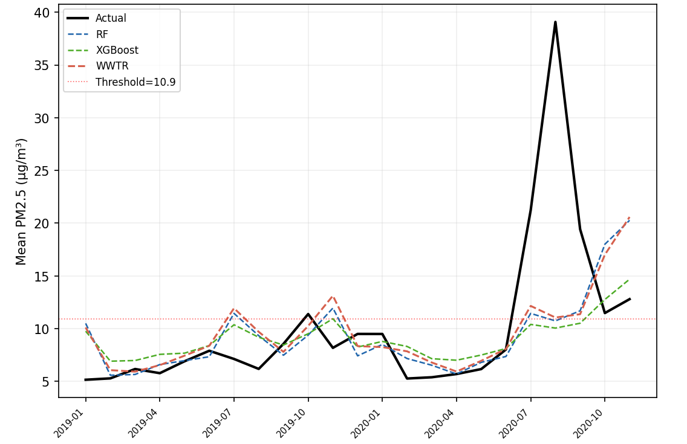
Figure 6. Actual vs predicted PM2.5 values. (EPA PM2.5 spike threshold of 35.4 µg/m³)
Overall, all models capture the general PM2.5 trend but struggle with extreme spikes. WWTR tracks high PM2.5 peaks more closely than the baseline models, improving the representation of hazardous events.

4.5 Correlation Analysis of Two Channels Results
The linking analysis shows that wildfire variables have statistically significant relationships with PM2.5 levels. Average FRP has the strongest correlation with PM2.5 at lag 0, while lagged fire variables also remain significant. This suggests that wildfire intensity and recent wildfire activity provide useful signals for explaining air-quality variation.
Fire variable | Lag | Pearson r | p-value | Significant
fire_count | 0 | 0.0722 | 0.000168 | Yes
fire_count | 1 | 0.0864 | 8E-06 | Yes
fire_count | 2 | 0.0904 | 4E-06 | Yes
avg_frp | 0 | 0.3904 | 0.0 | Yes
avg_frp | 1 | 0.1889 | 0.0 | Yes
avg_frp | 2 | 0.0911 | 3E-06 | Yes
Table 6. Lag correlation between wildfire variables and PM2.5. Average FRP shows the strongest immediate relationship with PM2.5.
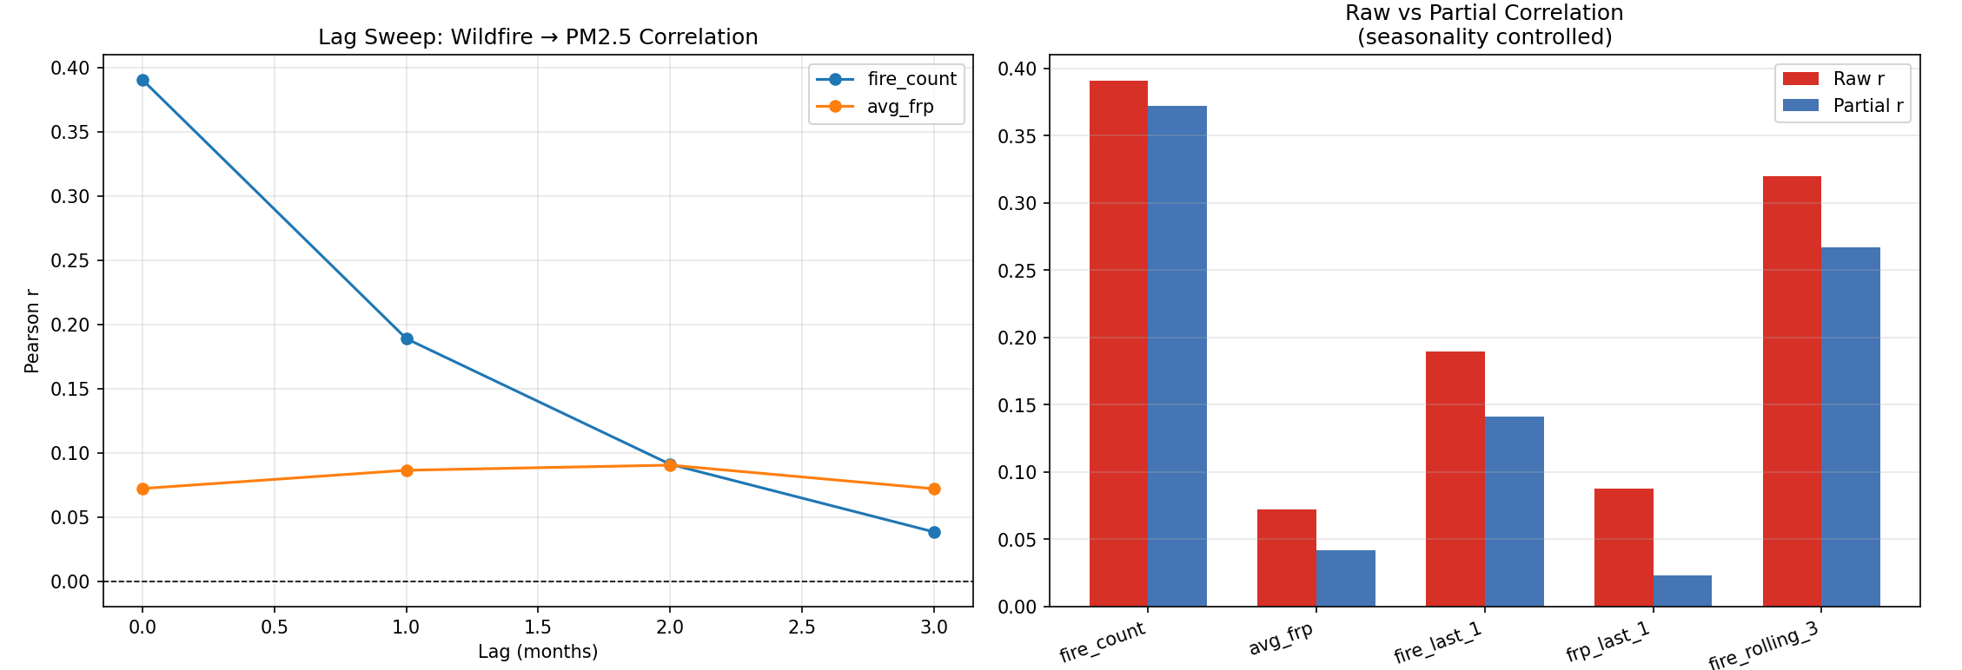
Figure 7. Lag correlation between wildfire variables and PM2.5.
Wildfire activity, especially average FRP, shows the strongest correlation with PM2.5 at 0-month lag (approximately 0.39), and the correlation decreases over longer lags. After controlling for seasonality, key wildfire indicators such as fire count and rolling fire activity still retain positive association with PM2.5.
The final linking comparison evaluates wildfire and PM2.5 features together for predicting next-month PM2.5.
Model | MAE | RMSE | R²
Gradient Boosting | 4.809 | 10.39 | 0.045
VAR / Granger | 3.325 | 5.529 | 0.451
Table 7. Linking model comparison for predicting next month's PM2.5 using wildfire and PM2.5 features.
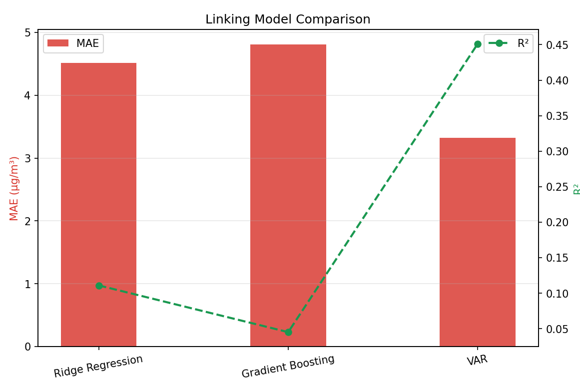
Figure 8. Linking model comparison for predicting next month's PM2.5 using wildfire and PM2.5 features.
The VAR/Granger model performs better than Gradient Boosting in the linking task, achieving lower MAE and RMSE and higher R². This suggests that temporal dependence is important when analyzing wildfire-PM2.5 relationships.

5. Conclusion and Future Work
This project developed a two-channel machine learning framework for wildfire risk prediction and PM2.5 air-quality analysis in California. Channel I used NASA FIRMS VIIRS wildfire detections to predict next-month high wildfire activity at the county-month level. The proposed WFR-XGB model improved high-fire recall from 0.57 to 0.73 compared with standard XGBoost, making it more useful for early-warning applications. Channel II used EPA AQS PM2.5 data to predict air-quality trends and applied WWTR, an asymmetric wildfire-weighted regression model designed to reduce missed PM2.5 spike events.
The linking analysis showed that wildfire variables, especially average FRP and recent fire-history features, are associated with PM2.5 variation. This supports the idea that wildfire activity and air-quality degradation can be studied together using county-month prediction models.
Future work can improve this system by adding meteorological variables such as wind speed, wind direction, humidity, temperature, and drought index. Daily or weekly prediction could also improve operational usefulness. Another important extension is to include county adjacency and smoke transport direction, since wildfire smoke can affect neighboring counties. Finally, future work can connect wildfire and PM2.5 predictions with public health outcomes such as asthma-related emergency department visits.

References
[1] Agrawal, N., Nelson, P. V., and Low, R. D. 2023. A Novel Approach for Predicting Large Wildfires Using Machine Learning towards Environmental Justice via Environmental Remote Sensing and Atmospheric Reanalysis Data across the United States. Remote Sensing 15(23), 5501. https://doi.org/10.3390/rs15235501
[2] Illarionova, S., Shadrin, D., Gubanov, F., Shutov, M., Tasuev, U., Evteeva, K., Mironenko, M., and Burnaev, E. 2025. Exploration of geo-spatial data and machine learning algorithms for robust wildfire occurrence prediction. Scientific Reports 15, 10712. https://doi.org/10.1038/s41598-025-94002-4
[3] Bhowmik, R. T., Jung, Y. S., Aguilera, J. A., Prunicki, M., and Nadeau, K. C. 2023. A multi-modal wildfire prediction and early-warning system based on a novel machine learning framework. Journal of Environmental Management 341, 117908. https://doi.org/10.1016/j.jenvman.2023.117908
[4] Guo, W., Hu, Z., Jin, L., Xu, Y., and Gonzalez, M. C. 2025. DeepAir: Deep Learning and Satellite Imagery to Estimate High-resolution PM2.5 at Scale. Machine Learning: Science and Technology 6(1), 015057. https://doi.org/10.1088/2632-2153/adb67a
[5] Liu, Z., Ji, D., and Wang, L. 2024. PM2.5 concentration prediction based on EEMD-ALSTM. Scientific Reports 14(1), 12636. https://doi.org/10.1038/s41598-024-63620-9
[6] Chen, Q., Ding, R., Mo, X., Li, H., Xie, L., and Yang, J. 2024. An adaptive adjacency matrix-based graph convolutional recurrent network for air quality prediction. Scientific Reports 14(1), 4408. https://doi.org/10.1038/s41598-024-55060-2
[7] Wang, Y., Tian, S., and Zhang, P. 2024. Novel spatio-temporal attention causal convolutional neural network for multi-site PM2.5 prediction. Frontiers in Environmental Science 12, 1408370. https://doi.org/10.3389/fenvs.2024.1408370
[8] Liao, K., Buch, J., Lamb, K. D., and Gentine, P. 2025. Simulating the air quality impact of prescribed fires using graph neural network-based PM2.5 forecasts. Environmental Data Science 4, e11. https://doi.org/10.1017/eds.2025.4
[9] Qiu, M., Li, J., Gould, C. F., Jing, R., Kelp, M., Childs, M., Kiang, M., Heft-Neal, S., Diffenbaugh, N., and Burke, M. 2024. Mortality Burden From Wildfire Smoke Under Climate Change. NBER Working Paper 32307. https://www.nber.org/papers/w32307
[10] Just, A. C., Arfer, K. B., Rush, J., Lyapustin, A., and Kloog, I. 2025. XIS-PM2.5: A daily spatiotemporal machine-learning model for PM2.5 in the contiguous United States. Environmental Research 271, 120948. https://doi.org/10.1016/j.envres.2025.120948
[11] Li, L., Girguis, M., Lurmann, F., Pavlovic, N., McClure, C., Franklin, M., Wu, J., Oman, L. D., Breton, C., Gilliland, F., and Habre, R. 2020. Ensemble-based deep learning for estimating PM2.5 over California with multisource big data including wildfire smoke. Environment International 145, 106143. https://doi.org/10.1016/j.envint.2020.106143
[12] NASA FIRMS. VIIRS 375 m Active Fire Data. NASA Earthdata/FIRMS. Available: https://earthdata.nasa.gov/firms
[13] U.S. Environmental Protection Agency. Air Quality System (AQS) AirData: Daily PM2.5 FRM/FEM Mass, Parameter Code 88101. Available: https://aqs.epa.gov/aqsweb/airdata/download_files.html
[14] U.S. Census Bureau. 2020 TIGER/Line Shapefiles: U.S. Counties and Equivalent Entities. Available: https://www.census.gov/geographies/mapping-files/2020/geo/tiger-line-file.html

